. 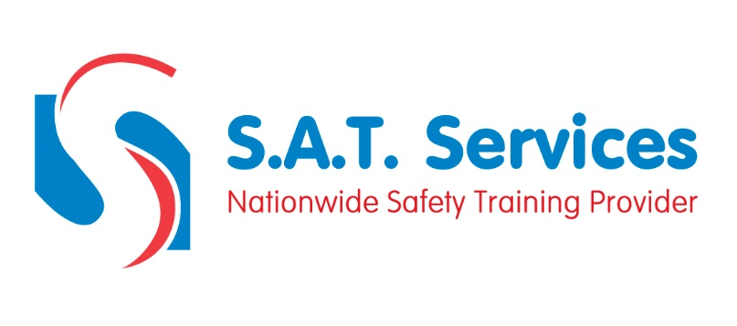
COURSE CONTENT AND SYLLABUS

Introduction
Machine Classification
Health and Safety at Work Act 1974
Provision and Use of Work Equipment Regulations 1998
Lifting Operations and Lifting Equipment Regulations 1998
Afternoon
Personal Protective Equipment (PPE) at Work Regulations 1992
Work At Height Regulations 2005 / Additional Regulations
Mobile Elevating Work Platforms - Operator Training
Theory test
Course evaluation

