. 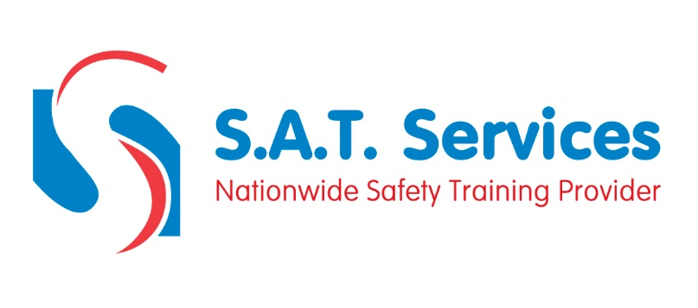
COURSE CONTENT AND SYLLABUS

Introduction
Legislation, Regulations & Guidance
Theory Assessment (Test Paper)

