. 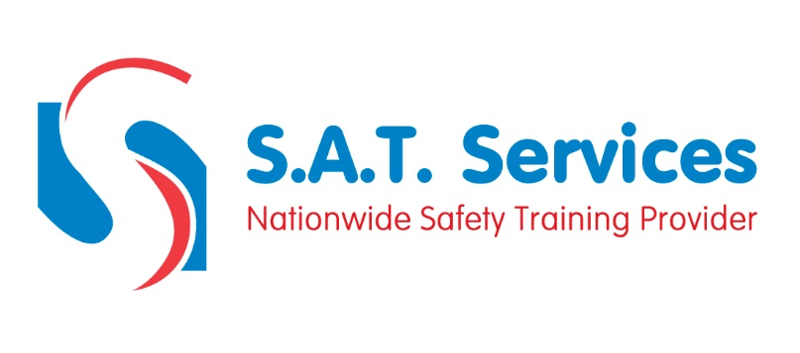
COURSE CONTENT AND SYLLABUS

Employer’s and employee’s legal responsibilities
Pre-use inspections and selection of lifting tackle
LOLER regulations 1998
Load limitations
Slinging methods
Different types of loads
Accurate guiding of loads
Centre of gravity
Hand signals

