. 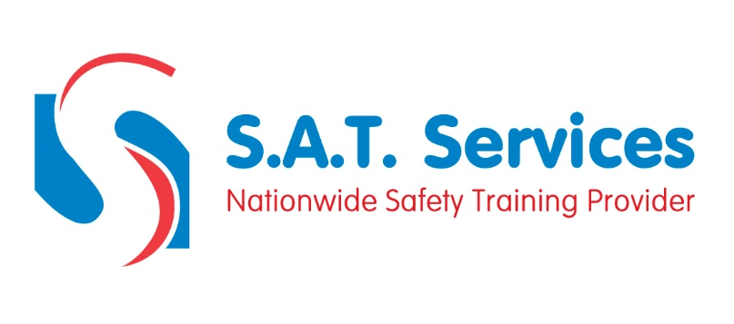
COURSE CONTENT AND SYLLABUS

Course registration
Course introduction
Scene of An Accident
Emergency Action Plan
Unconscious Patients
Choking
Amputation
Embedded Objects
Poisoning
Broken Bones
Heart Attack
Diabetes
Asthma
Cardio Pulmonary Resuscitation
Recovery Position
Bleeding & Shock
Eye Injury
Nose Bleed
Burns
Spinal Injury
Stroke
Fitting / Epilepsy
Anaphylaxis
Priorities Of Treatment
Employers Responsibilities With Regard To First Aid
First Aid Kits
Course Finish

