. 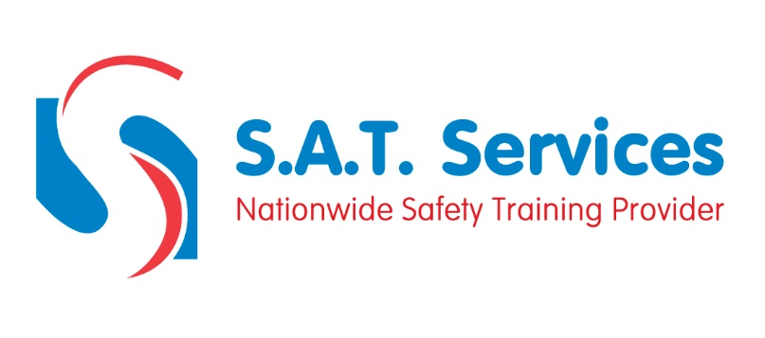
COURSE CONTENT AND SYLLABUS

Employer’s and employee’s legal responsibilities
Common hazards when lifting & moving
Accident statistics
Risk assessment
Causes of injury & strain
Main parts of the spine
Correct handling techniques
Weight limits and guidelines
Assessment of individual safe limits

