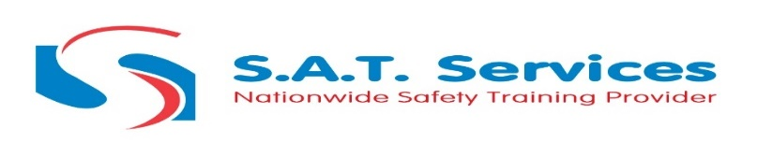
1B Course Information
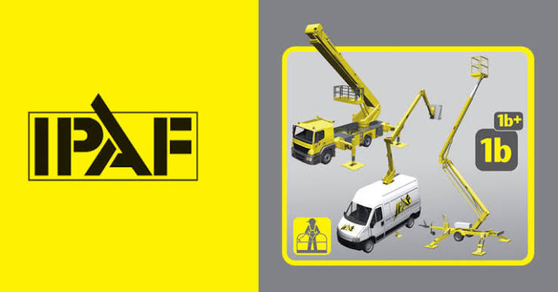
This IPAF 1B training course is designed to help operators prepare and safely operate static boom lifts. The course will consist of classroom-based tutorials, demonstrations and practical and written tests.
You will train at one of our IPAF accredited training centres where you will learn:
- How to safely drive and manoeuvre static boom lifts
- Relevant health and safety regulations
- IPAF best practices for MEWPs
Why This Course Matters for Static Boom Lift Operators
Using a static boom lift without proper training poses serious risks. This course ensures you have the competence and confidence to operate safely and meet legal expectations, wherever your work takes place.
Key reasons to complete this training:
- Satisfy your legal duty under UK health and safety law
- Reduce the risk of accidents, injury, and equipment damage
- Gain certification required by many employers and job sites
- Improve efficiency and confidence when working at height
- Strengthen your qualifications and job prospects in a high-risk field
Whether you're working in construction, maintenance, or industrial access, this training helps build a safer and more professional workforce.

What You’ll Learn on the IPAF OP: Mobile Boom 1B Training Course
This IPAF 1B training course provides the essential knowledge and practical skills to operate static boom lifts safely across various environments. Whether you’re a new operator or need to renew your licence, the course helps ensure safe, responsible, and legally compliant MEWP operation.

During the course, you will learn how to:
- Identify static boom lifts and understand their safe applications
- Conduct pre-use inspections and follow correct setup procedures
- Operate the equipment safely under different site conditions
- Recognise common hazards and implement safe working practices
- Understand relevant health and safety laws and IPAF best practice
- Respond appropriately to emergencies and rescue procedures
- Pass the required theory and practical assessments for certification

Successful delegates will receive an IPAF 1B certificate and a digital EPAL Card, accessible via the IPAF ePAL app.
IPAF Certification
Successful candidates will receive the IPAF 1B qualification and an IPAF Certificate of Training for this. These will both be accessible via the IPAF ePAL app, available on Android and iOS smartphones, which also includes a logbook and safety information. If a physical PAL card and certificate are required these must be arranged with the training department prior to the course start date, at an additional charge of £30 + VAT.
Who Should Take the IPAF OP: Mobile Boom 1B Training Course?
This course is suitable for anyone who operates vehicle-mounted or trailer-mounted boom lifts (MEWPs in IPAF Category 1B) as part of their job. It’s also ideal for operators renewing their PAL Card or those expanding their access platform skills.
This includes:
- Construction and site workers
- Facilities and maintenance teams
- Signage and lighting installers
- Cleaning and high-access contractors
- Individuals working in utilities, telecoms, or infrastructure
- Anyone whose employer or site requires valid IPAF certification
No prior experience is needed, but you must be physically fit and able to understand spoken and written English.
Frequently Asked Questions
1. Do I need this course if I’ve already used a static boom lift before?
Yes. Even if you have experience, most employers and sites require official IPAF certification (PAL Card) to prove competence. This course provides the formal training and qualification needed to meet industry and legal requirements.
2. What’s the difference between IPAF 1B and other IPAF categories like 3A or 3B?
IPAF 1B covers static boom lifts, such as vehicle- or trailer-mounted platforms that stay in place during use. IPAF 3A covers mobile vertical lifts (like scissor lifts), and 3B covers mobile boom lifts (self-propelled booms). You should take the course that matches the type of MEWP you'll be operating.
3. How long is the IPAF 1B certification valid for?
Your IPAF EPAL Card is valid for five years. After that, you’ll need to complete a renewal course to stay certified and compliant.
4. What if I fail the practical or theory test?
If you don’t pass on the first attempt, your instructor will provide feedback and, in many cases, you can rebook a retest (At a cost!). It’s important to come prepared, but support is available if needed.
5. Will I get a physical PAL Card or is it digital only?
By default, you'll receive your IPAF certificate and EPAL Card via the IPAF ePAL app, which also includes your logbook and safety info. If you prefer a physical card and paper certificate, you can request this before the course for an additional £30 + VAT.
Course Objectives
This programme is designed for the operators of Mobile Elevating Work Platforms (MEWPs) – including static booms - and those looking to renew their operator licences.
You should enrol on our IPAF 1B training course if:
- You operate static boom lifts
- You need to renew an expired operator licence
Who Should Attend
This programme is designed for the operators of MEWPs, renewal of PAL cards or for those looking to learn how to operate MEWPs. The course will consist of classroom-based tutorials, demonstrations and practical and written tests.

