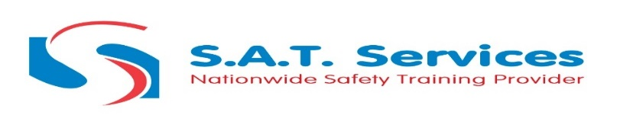
IPAF 3A 3B Course Information
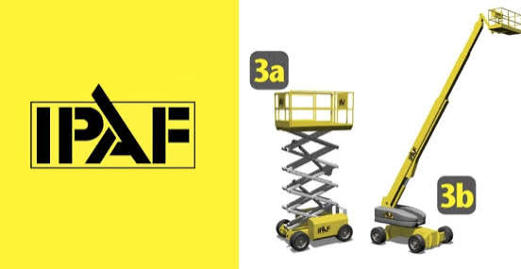
- Duration: 1 day (minimum 7.5 hours of instruction)
- Certification: Certification: IPAF 3A and 3B operator certification. Valid for 5 years, internationally recognised
- Delivery: In-person at our training centres, or on your site
- Max delegates: 4 per instructor for hands-on, quality training or 8 delegates x 2 instructors
- Accreditation: Fully accredited by IPAF (International Powered Access Federation)
IPAF 3A 3B Course Programme
The course runs for one full day and is split between classroom-based theory and practical machine operation. All courses start prompt — please ensure delegates arrive in good time, as late comers may not be admitted.
Registration and Induction
On arrival, you will be welcomed by your IPAF-certified instructor and given an overview of the day ahead. A short pre-course knowledge check helps the instructor gauge the group’s experience level and tailor the session accordingly.
Classroom Theory Training
The morning session covers the essential theory you need to operate MEWPs safely. Topics include:
- Health and Safety at Work Act and Working at Height Regulations
- Accident prevention and the importance of personal protective equipment (PPE)
- MEWP machine categories and their structural components
- Pre-use inspection and handover requirements
- Safe operating methods, hazard awareness, and emergency procedures
- The IPAF Operator Safety Guide (IS ON YOUR IPAF EPAL APP download before coming)
Practical Training
The afternoon is dedicated to hands-on machine operation under the supervision of your instructor’(s). You will:
- Perform pre-use machine inspections and safety checks
- Learn to correctly wear and adjust a safety harness
- Practise manual and auxiliary descent procedures
- Operate scissor lifts (3A) and boom lifts (3B) safely, including driving, positioning, and manoeuvring
- Navigate typical workplace hazards while operating at height
IPAF 3A 3B Course Assessment
Assessment takes place in two parts on the same day:
Theory Assessment
At the end of the classroom session, you will complete an open-book, multiple-choice theory exam. The assessment is based on the content covered during the morning tutorials. You must pass the theory assessment before progressing to the practical training and assessment.
Practical Assessment
At the end of the practical session, you will be assessed against IPAF’s practical test standards. You must demonstrate that you can safely and competently prepare, inspect, and operate MEWPs in the 3A and 3B categories. The assessment is carried out by your IPAF-certified instructor.
What if I don’t pass? If you do not pass the theory, you will not progress to the practical and can return another day to re-complete. If you pass the theory but fail one or both elements of the practical, you can return for a half day practical re-sit on another day.
Certification and What You Receive
On successful completion of the course, you will receive:
- IPAF 3A and 3B operator certification, valid for 5 years
- Certification added to your digital PAL Card, accessible via the IPAF ePAL app on iOS and Android
- Digital logbook for recording your operating hours and experience
- IPAF Operator Safety Guide and safety resources within the ePAL app
Your certification is valid for 5 years from the date of training. All IPAF qualifications are now issued digitally via the ePAL app as standard. If you require a physical PAL Card and printed certificate, these can be arranged for £30 + VAT — please contact the training team before your course start date.
What to Bring
All delegates must bring appropriate personal protective equipment (PPE) to the course:
- Hard hat (chin strap preferred)
- Safety harness with short restraint adjustable lanyard
- Hi-vis vest
- Safety footwear (steel or composite toe cap boots)
- Eye protection
Don’t have a harness? We have Harness kits for you free of charge to use on the day
IPAF 3A 3B FAQs
What is IPAF 3A 3B?
IPAF 3A 3B refers to the two machine categories covered by this operator training course. 3A covers Mobile Vertical platforms such as scissor lifts, and 3B covers Mobile Boom platforms such as cherry pickers and articulated boom lifts. The combined course trains you to safely operate both types of MEWP (Mobile Elevating Work Platform) in a single day.
What does IPAF 3A and 3B cover?
The course covers everything you need to operate scissor lifts and boom lifts safely and in line with UK health and safety legislation. This includes classroom theory on the Health and Safety at Work Act, Working at Height Regulations, accident prevention, and hazard awareness. The practical element covers pre-use machine inspections, safe operation and manoeuvring of MEWPs, harness fitting, and emergency descent procedures. You will complete both a theory assessment and a practical assessment on the day.
Does IPAF 3A and 3B cover 1B?
No. The IPAF 3A and 3B course covers mobile vertical platforms (scissor lifts) and mobile boom platforms (cherry pickers) only. It does not include 1B, which covers static boom lifts such as van-mounted or trailer-mounted platforms. If you need all three categories, we offer the IPAF 3A, 3B and 1B Combined Operator Training Course, which covers all three in a 2-day programme.
What is the difference between IPAF 3A and 3B?
IPAF 3A covers Mobile Vertical machines, such as scissor lifts, which move the operator straight up and down. IPAF 3B covers Mobile Boom machines, such as cherry pickers and articulated boom lifts, which can extend both upward and outward for greater reach. This combined course trains you on both categories.
How long does IPAF 3A and 3B last?
The course is completed in one full day, with a minimum of 7.5 hours of instruction. Your IPAF EPAL Card is then valid for 5 years from the date of training.
What safety helmet is required for IPAF 3A 3B?
You must bring a safety helmet to the course. A helmet with a chin strap is preferred, as it is more secure when working at height and operating MEWPs. Standard hard hats without a chin strap are generally accepted, but a chin strap helmet is recommended best practice and is increasingly required on UK construction sites. Your helmet should meet EN 397 or equivalent standards.
Have more questions? Email us @ info@satservices.org
Related courses
Looking to expand your qualifications or add to your team’s skills? These courses complement the IPAF 3A 3B training:
- IPAF 3A 3B & 1B– Add static boom lift (1B) certification to your 3A and 3B qualifications. Covers scissor lifts, cherry pickers, and van-mounted or trailer-mounted platforms in one 2-day course. Ideal if your work involves a wider range of powered access equipment.
- IPAF HARNESS AWARENESS & HARNESS USER – Essential for anyone who needs to wear a safety harness while operating boom lifts. Combines online Harness Awareness training with a practical Harness User assessment at one of our centres.
- IPAF 3A & 3B WITH BOLT ON HARNES USER COURSE – Complete the IPAF 3a3b course, combined with online Harness Awareness training to enable you to complete the Harness User and 3a3b together in the same day.
- PASMA COURSES - Towers For Users, Low Level Access, Towers On Stairs – Learn to safely assemble, dismantle, move, and inspect mobile access towers and low-level Equipment. PASMA certification is valid for 5 years and widely required across construction and maintenance.
Course Objectives
The IPAF 3A and 3B Operator Training Course teaches you how to safely operate Mobile Elevating Work Platforms (MEWPs), including scissor lifts (3A) and cherry pickers and boom lifts (3B). The course combines classroom theory with hands-on practical training, giving you the skills and knowledge to work at height safely and in line with current UK health and safety legislation.
On successful completion, you will receive your IPAF 3A and 3B operator certification, which is added to your IPAF PAL Card - the digital wallet that holds all your IPAF qualifications. Your certification is valid for 5 years and is recognised on construction sites and workplaces worldwide.
This course covers two IPAF machine categories:
- IPAF 3A – Mobile Vertical: Scissor lifts and mobile vertical personnel platforms. These machines elevate the operator straight up and down.
- IPAF 3B – Mobile Boom: Self-propelled boom lifts, articulated booms (cherry pickers), and telescopic boom lifts. These machines can reach upward and outward for greater range.
Who Should Attend
This course is suitable for anyone who operates or will operate scissor lifts or boom lifts in the workplace. It is ideal for:
- Construction site operatives who need to use MEWPs as part of their daily work
- Industrial and maintenance contractors working at height
- Electricians, painters, decorators, cleaners, and other trades who use powered access equipment
- Facilities and property management teams responsible for building maintenance
- First-time operators who have never used MEWPs and need their initial PAL Card
- Experienced operators whose IPAF PAL Card has expired and needs renewing
No formal qualifications or prior experience are required. Delegates must be at least 16 years old, physically fit, and able to read and understand safety notices and manuals.

