
IPAF Harness Awareness & User Course Information
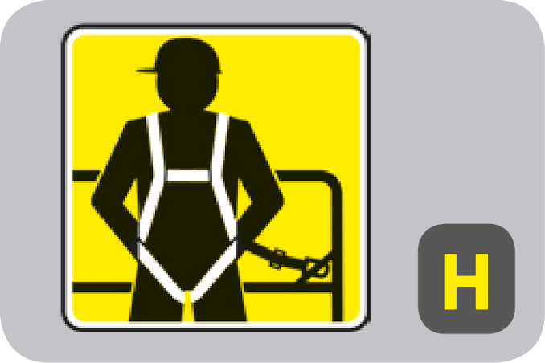
ABOUT THE COURSES
According to IPAF data, falls from the platform is one of the major causes of injury or fatality associated with using MEWPs. Awareness and understanding of how to correctly use a harness is critical to safe operation of boom-type MEWPs. IPAF offers three harness courses to meet the needs of different candidates;
- Harness Awareness Course (HA)
- Harness User Course (HU)
- Harness Inspector Course (HI)
WHO SHOULD TAKE THESE COURSES?
Candidates who do not need to personally use or wear a harness should, take only the HA Course (theory training & test) which can be completed remotely as eLearning,
or in-person at an IPAF training centre. Candidates typically include managers, planners, safety professionals and supervisors.
Candidates who do need to use or wear a harness themselves should first take the HA Course and then attend an IPAF training centre to take their HU Course practical assessment (this can be incorporated into a candidate’s MEWP Operator Course). Candidates are generally MEWP operators.
Candidates who are responsible for inspecting their company’s personal fall protection equipment (PFPE) and maintaining inspection records (including those required by law), should first take the HA and HU courses, followed by the HI Course. Candidates are mostly company harness/safety inspectors.
HOW LONG IS EACH COURSE?
This depends on which course(s) are taken and which formats are chosen. For example, the HA Course alone could be taken as eLearning, remotely, in half a day or less.
Candidates taking both the HA and HU courses could do so consecutively, in-person at an IPAF training centre, led by an instructor, with a duration of half a day. Or they could have completed the HA Course by eLearning prior to attending an IPAF training centre.
Candidates taking the HI Course must have previously passed the HA and HU courses prior to taking the HI Course in-person, at an IPAF training centre, led by an instructor, with a duration of half a day.
YOU WILL LEARN
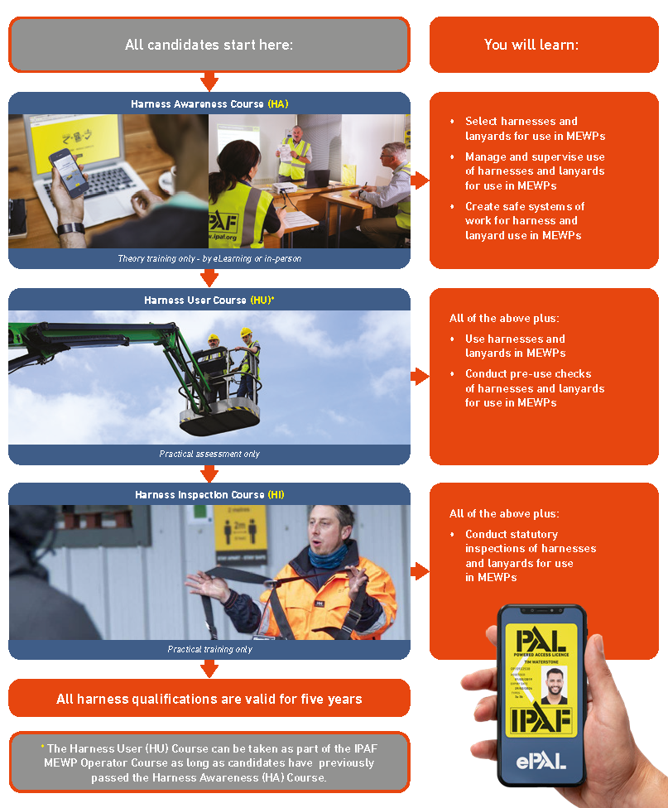
QUALIFICATION
Upon successful completion of the Harness Awareness Course (HA), Harness User Course (HU), or Harness Inspector Course (HI), candidates receive a digital certificate, accessed via the IPAF ePAL app.

