
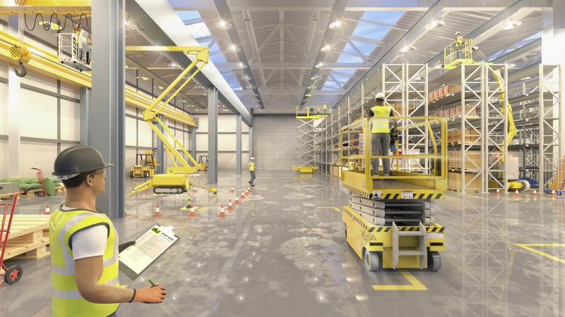
IPAF Mewps For Managers and Inspection Course Information
Companies that use MEWPs need to know what their management responsibilities are – and what their legal responsibilities are. The course covers what managers need to know about the safe use of MEWPs on site, from planning the job and conducting a risk assessment, to selecting the right equipment and mitigating all possible risks. Under UK health and safety legislation, specifically, the Provision and Use of Work Equipment Regulations 1998 (PUWER) and the Work at Height Regulations 2005, employers must train all employees who plan, supervise and manage work at height and the use of equipment for such work.
Course Objectives
The IPAF MEWPs for Managers course is essential training for anyone who supervises or plans working at height. Developed in conjunction with major contractors, the course covers topics including the correct selection of platforms, regulations associated with work at height, emergency procedures, equipment maintenance and pre-use checks. Practical demonstrations are also included if machines are available.
Certification
Successful candidates will receive the MEWP for managers qualification, and an IPAF Certificate of Training. These will both be accessible via the IPAF ePAL app, available on Android and iOS smartphones, which also includes a logbook and safety information. If a physical PAL card and certificate are required these must be arranged with the training department prior to the course start date.
Who Should Attend
Employers, project managers, foremen and supervisors working in a broad range of industries such as construction, facilities management, retail, airports and arboriculture. Anyone who is responsible for planning and overseeing the use of MEWPs on their job site.

