
PAV Course Information
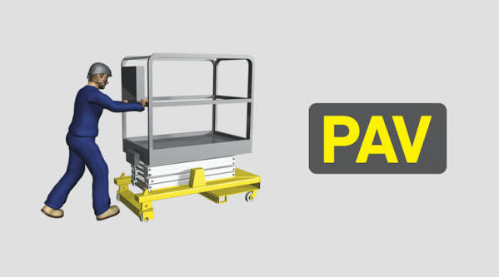
Course Aim
This industry leading course will provide delegates with the knowledge and practical skills to safely operate powered access equipment. This IPAF Operator course with practical training session and assessment covers Push Around Vertical (PAV) platforms. Push Around Verticals are essentially small, simple static vertical machines with no mechanical drive and are physically pushed around.
Who Should Attend?
Those who operate, supervise or manage the use of powered access equipment including Push Around Vertical platforms (PAV). The course can be run as an IPAF category operator add-on / familiarisation course.
Agenda
Theory
• Introduction and pre-course theory test
• MEWP regulations and guidance
• Machine types and use
• Structural parts
• Familiarisation and pre-use inspection
• Safe operating methods and hazards
• Written theory test
Practical
• Practical training
• Practical assessment
Course Duration
This is a half day course.
Certification
Delegates successfully completing the course will receive an IPAF Certificate and Powered Access Licence (PAL) Card valid for 5 years

