
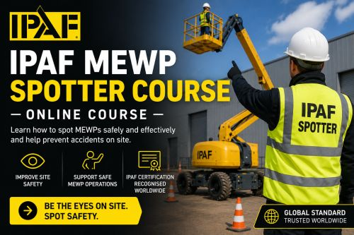
IPAF SPOTTERS Course Information
What is a MEWP Spotter?
A MEWP Spotter is a specific role assigned to one or more people to observe MEWP operations onsite, in real-time, and, where necessary, communicate with the MEWP Operator to direct them to manoeuvre the MEWP safely away from any obstacles or hazards that may be beyond the MEWP Operator’s line of sight. The MEWP Spotter(s) and MEWP Operator work together as a team to ensure safe, efficient MEWP operations.
Who is the course for?
Anyone who needs to assist a MEWP Operator to safely manoeuvre a MEWP into position, particularly in situations where the Operator has restricted visibility. The Spotter role is ‘another pair of eyes’ and IPAF recommends all Operators, supervisors and site managers also take the course to ensure everyone on site understands the Spotter’s role, hand signals and where the Spotter should be safely positioned. As a result, there are no entry requirements for this course.
Why was the course created?
Contractors first identified the need to IPAF to create a universal, dedicated MEWP Spotter course to improve safety on their sites and across the wider industry. Many contractors already routinely assign Spotters to direct Operators as part of their risk assessment because doing so has seen a reduction in incidents.
No one can see around corners and, by having ‘another pair of eyes on the job’ ensures the Operator is alerted to any hazards and obstructions that lie beyond their line of sight.
Previously, many contractors provided their own training to Spotters, but this resulted in discontinuity and sometimes confusion, and any disparity breeds potential for miscommunication that could result in incidents.
The new IPAF MEWP Spotter Training Course provides a universal method of working as a Spotter and Operator team, that keeps everyone safe while increasing the overall efficiency of operations. When everyone uses the same method of working, everyone understands the same hand-signals, positioning, and requirements, playing an essential role in keeping themselves and others safe.
Is there any practical training in the course?
No, the course is completely theory based and online due to the role being observational and procedural, focusing on hazard awareness, clear communication with Operators, and decision-making, rather than machine operation, particularly as no two machines or site setups are the same.
What formats is the course available in?
The course is in eLearning format only, with Facial Recognition. The convenience of taking the course online, remotely, as eLearning, meets the needs of contractors and individual candidates, enabling the course to be completed on a PC, MAC, tablet or mobile phone.
How long is the course?
Approximately two and a half hours.
Is the course legislation neutral?
Yes.
How long is the qualification valid for?
Five years.
HOW WILL THE CATEGORY APPEAR ON LICENCES?
This course is certificate only, so the category will not appear on licences.
What languages is the course available in?
Currently, English only. This is because the request to create the course was made by English speaking contractors. The course will be available to English-speaking Training Centres in the countries listed below. However, any Training Centre, regardless of location, can offer it to their candidates in English – they would simply need to contact IPAF’s Customer Services to request it.

