

TOWERS FOR USER - COURSE INFORMATION & SYLLABUS

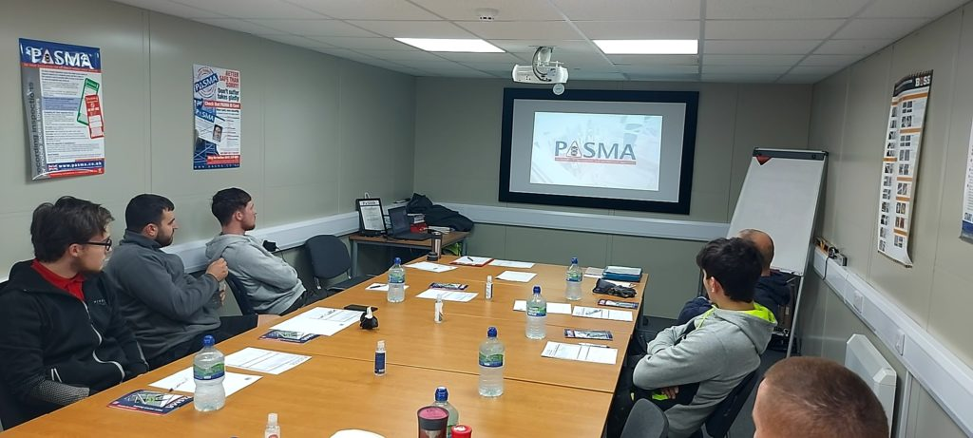

Duration: 1 day

Theory & Practical: Yes

Standards: EN 1004

Mobile access towers are straight up and down, single bay structures with four legs and wheels that can reach heights of 8m outdoors and 12m indoors. These lightweight structures can be assembled and dismantled quickly and easily, with collective fall prevention in place throughout.
It’s no wonder they’re a familiar sight in workplaces across the world, used by everyone from facilities managers and signage companies to stonemasons and event organisers.

What's covered?

Through a combination of theory and practical work, you will learn about:
- Work at height responsibilities of employers, employees and suppliers
- Standards affecting the manufacture and use of mobile access towers
- Where to find crucial safety information
- When it’s safe to use a mobile access tower, and when it’s not
- Carrying out pre-use checks and post-assembly inspections on mobile access towers
- Assembling and dismantling a mobile access tower using approved methods
- Good practices for the safe use of mobile access towers
- Accessing a platform safely
- Moving a mobile access tower
- The components used in a mobile access tower
- Identifying hazards in the work environment
- Avoiding personal health hazards

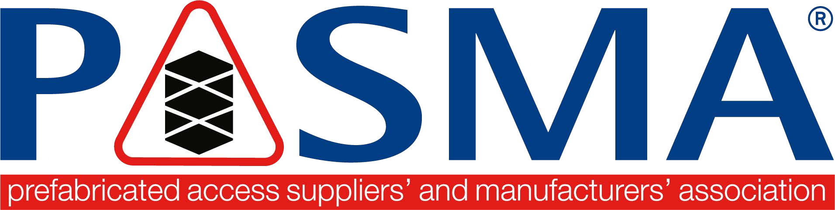
COURSE SYLLABUS

Course Title | Towers for Users
Duration | 1 day
Who will benefit from this course | Personnel who will be responsible for the assembly, dismantling, alteration, moving and inspecting of mobile access towers
Learning Objectives | How to safely assemble, dismantle, relocate and alter a mobile access tower without risk of personal injury to the delegate or others
Method | Instruction both in theory and practical sessions
Assessment | Theory and practical assessments with a pass mark of 80% in both
Personal Protective Equipment | Suitable head / footwear /eye / glove protection during the practical session. Hard hat, preferably with chin strap
Course content | Legislation, Regulations and Guidance affecting working at height with mobile access towers, PASMA Code of Practice; Product Standards EN 1004 - 1 assembling, altering and dismantling towers incorporating current best practice and approved build methods for fall protection, inspection of completed mobile access towers and completion of Tower Inspection Records; hazards affecting the use of mobile access towers and how to avoid
Instructor delegate ratio | Maximum of 1 Instructor: 12 Delegates
Venue requirements | A suitable classroom to accommodate 12 delegates for the theory session and both an indoor / outdoor practical area with a minimum free height of 6 metres are prerequisites
Supporting Documents | Course notes booklet and the current Code of Practice will be issued to all delegates who attend the course. These may be electronic/digital copies
Award | A PASMA Photocard will be issued to successful delegates who complete both theory and practical assessment sessions at the level they attend. Certificates, if required, can be requested. The Photocard will state the expiry date
Literacy, Fitness & Health Statement | Since the safe use of mobile access towers requires that you consult safety notices and read and thoroughly understand the manufacturer’s instruction manual, literacy and language comprehension are important requirements for any tower user.  Similarly, since the assembly and use of mobile access towers can be physically demanding, users should be physically fit and in good health, and should generally, not have problems with eyesight or hearing, heart disease, high blood pressure, epilepsy, fear of heights, vertigo, giddiness, difficulty with balance, impaired limb function, alcohol or drug dependence, including prescribed drugs or psychiatric illness  You should also consider how the effects of extremes of temperature – heat  and cold; lack of nutrition – fasting; and lack of water – dehydration, can impair your ability to work effectively  If you have any problems with literacy or language comprehension, are pregnant, or have any doubts about your fitness to use mobile access towers, you must bring them to the attention of your employer. This need not preclude you from using mobile access towers, provided your employer conducts an assessment and is able to put into place adequate measures to take account of any difficulties you may have
Qualifications & Experience | No formal qualifications or experience are necessary, but it would be beneficial if delegates had a basic understanding of work at height issues

