

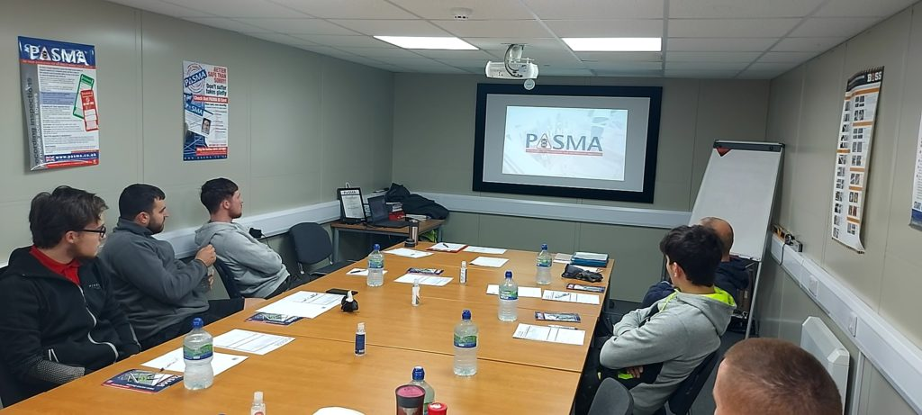

TOWERS FOR MANAGERS & COURSE INFORMATION & SYLLABUS

Duration: 1 day Theory Based Only

Practical: No

Standards: EN 1004, BS 1139-6, BS 8620

Managing people who use scaffold towers is a scary responsibility if you don’t know what good practice looks like. How can you be sure your workers have chosen the right tower, built a stable structure and aren’t going to fall off?

To comply with Work at Height Regulations, you must be competent to supervise work on towers. When breaching the regulations can have such big consequences for managers – even prison sentences – you’ll want to ensure you’re trained for the task.

PASMA Towers for Managers will equip you with the specialist knowledge you need to keep your towers accident-free zones. Spend one day at an approved PASMA training centre with an expert instructor and go back to work knowing how to:

Support your teams better on site

Send them home safe after every shift

Meet all your legal obligations

Inspect towers

Identify different tower types

Through a combination of theory and group exercises, the course teaches you what to look for from the ground – before, during and after work begins. There is no practical work involved in this course; it’s all classroom-based theory. No hard hats or tower climbing required!

What's covered?

Through a combination of theory and group discussions, you will learn about:

Work at height responsibilities of managers

Standards affecting the manufacture and use of towers

Where to find crucial safety information

When it’s safe to use a tower, and when it’s not

Different tower configurations

Identifying hazards in the work environment

Risk assessments

Rescue plans

Carrying out pre-use checks and post-assembly inspections on towers

The components used in a mobile access tower

Good practices for the safe use of mobile access towers

Behavioural competencies

Preventing personal health hazards

Is this the right course for me?

This course is aimed at people who don’t use towers themselves, like site managers, safety professionals and company directors. It’s suitable for anyone who manages or supervises tower operatives, including:

Those new to managing tower users

Those who already manage tower users but have never been formally trained

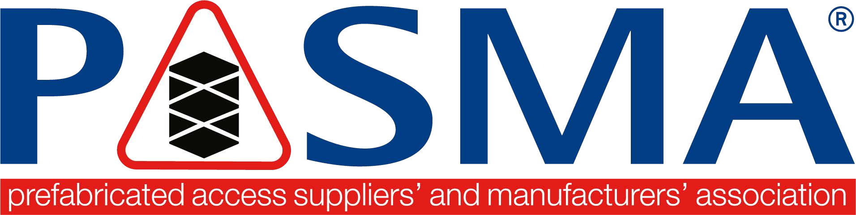
Those re-taking the course after an earlier qualification expires

Course Syllabus

Course Title | Towers for Managers
Duration | 1 day
Who will benefit from this course | Any person who has responsibility for managing people who use mobile access towers, ensuring that work is properly planned and organized, that those involved in carrying out the work are competent. The towers are correctly inspected and maintained
Learning Objectives | To learn about current legislation, regulations and guidance affecting work at height using mobile access towers
Method | Theory session with exercises
Assessment | Theory assessment with a pass mark of 80%
Personal Protective Equipment | None required
Course content | Current Legislation, Regulations and Guidance affecting work at height with mobile access towers. Code of Practice, reference to current instruction manuals incorporating current best practice for fall protection, fault-finding exercise, group case studies, completion of Tower Inspection Records, hazards affecting the use of mobile access towers; risk assessment/emergency & rescue plans and behavioral competencies
Instructor delegate ratio | Maximum of 1 Instructor: 12 Delegates
Venue requirements | A suitable classroom to accommodate 12 delegates for the theory session
Supporting Documents | Course notes booklet and the current Code of Practice will be issued to all delegates who attend the course. These may be electronic/digital copies
Award | A PASMA Photocard will be issued to successful delegates who complete the theory assessment sessions at the level they attend. Certificates, if required, can be requested. The PhotoCard will state the expiry date
Literacy, Fitness & Health Statement | Since the safe use of mobile access towers requires that you consult safety notices and read and thoroughly understand the manufacturer’s instruction manual, literacy and language comprehension are important requirements for any tower user.  Similarly, since the assembly and use of mobile access towers can be physically demanding, users should be physically fit and in good health, and should generally, not have problems with eyesight or hearing, heart disease, high blood pressure, epilepsy, fear of heights, vertigo, giddiness, difficulty with balance, impaired limb function, alcohol or drug dependence, including prescribed drugs or psychiatric illness  You should also consider how the effects of extremes of temperature – heat  and cold; lack of nutrition – fasting; and lack of water – dehydration, can impair your ability to work effectively  If you have any problems with literacy or language comprehension, are pregnant, or have any doubts about your fitness to use mobile access towers, you must bring them to the attention of your employer. This need not preclude you from using mobile access towers, provided your employer conducts an assessment and is able to put into place adequate measures to take account of any difficulties you may have
Qualifications & Experience | It would be envisaged that you will have a good working knowledge of the Work at Height Regulations and Health & Safety at Work Act 1974

